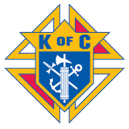

Entry Fee Includes – Donuts and Coffee
18 Holes of Golf with cart, Drinks, Hamburgers and Brats at 12 Noon
Pork Steak Dinner, Give Aways and Payouts following the round at:
Evansville KC Hall, 303 Broad Street, Evansville, IL 62242

Or Attendance Prizes (any amount)
Company Name: _________________________________________________
Address: ________________________________________________________
Contact Person: _________________________ Phone #: _________________

Sponsored by: Evansville Knights of Columbus Council 1952
For Additional Information, Contact: Mark McConachie 618-977-2168

