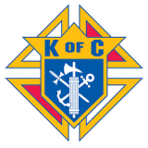

Entry Fee Includes – Donuts and Coffee
18 Holes of Golf with cart, Drinks, Hamburgers and Brats at 12 Noon
Pork Steak Dinner, Give Aways and Payouts following the round at:
Evansville KC Hall, 303 Broad Street, Evansville, IL 62242

****Entry Fee: $260.00 per team****
Team Captain: __________________________________________
Player 2: _______________________________________________
Player 3: _______________________________________________
Player 4: _______________________________________________

Sponsored by: Evansville Knights of Columbus Council 1952
For Additional Information, Contact: Mark McConachie 618-977-2168

